Quantitative Evaluation of LoRa RF Resiliency, Detectability, and Geolocation

Project Description
This project aims to characterize the performance of the LoRa Radio Frequency (RF) Chirp Spread Spectrum (CSS) modulation with methods used by Department of Defense (DoD). Valuable characteristics for DoD applications include Anti-Jam performance, Probability of Detection, and Probability of Geolocation. Communication technologies that perform well in these categories allow for reliable communication in situations where communication is expected to be jammed and/or scenarios where transmitter activity is monitored but desired to be undetected or non-locatable.
LoRa is an extremely low power, cost effective, and long-range method of wireless communication usually combined with the LoRa Wide Area Network (LoRaWAN) protocol for applications such as asset tracking, Internet Of Things (IoT), and sensor monitoring. LoRaWAN will not be used in this project and a custom, test protocol will be developed to evaluate the LoRa CSS modulation technique independently. Data rates for LoRa can reach 0.3-50kbps depending on spread factors chosen which can be considered limiting in many applications, but the performance benefits of long range (>15km LOS), extremely low cost, and extremely low power consumption could be highly desirable in certain applications.
Other desirable characteristics are low receiver sensitivity (-120 to -145dBm) and built in forward error correction coding. These characteristics could prove valuable for resiliency to jamming and operation at low SNR which gives LoRa the long range capabilities but could also prove valuable for low detection of probability performance when operating at lower output levels.
This evaluation is part of Capstone Project for the Wireless Embedded Systems, Masters of Advance Study Program at University California San Diego (UCSD) and is a collaboration with Naval Information Warfare Center, Pacific (NIWC Pac) Division 535. Equipment and facilities at NIWC Pac will be leveraged to conduct the evaluation and the UCSD Student will acquire, develop and bring Heltec LoRa radio development boards to the facility. The UCSD Student will develop necessary code on the Heltec boards to exercise end-end data through LoRa and run the tests with provided equipment training. A Paper of quantitative results and analysis will be delivered as the output of this project as the Minimum Viable Product (MVP).

Methods of Evaluation

Anti-Jam and Range Performance
This evaluation method assesses LoRa’s resilience to jamming and its ability to maintain reliable communication over extended distances under contested and low-probability-of-detection (LPD) conditions. The Range Ratio (Jamming) metric is defined as the ratio of the distance to a friendly receiver versus the distance to a jamming threat while the Range Ratio (Detection) metric is defined as the ratio of the distance to a friendly receiver versus the distance to a threat detector in an LPD environment.
By measuring these ratios under varying SNR levels and jamming scenarios, the project quantifies LoRa’s effectiveness in maintaining secure and reliable links in both jammed and covert operational environments

Detection Avoidance Performance
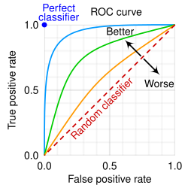
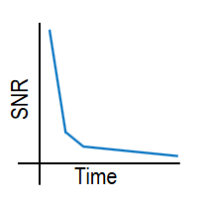
The detection avoidance evaluation quantifies LoRa’s ability to evade interception by analyzing its probability of detection under varying SNR conditions. This assessment relies on two key graphical tools: the Receiver Operating Characteristic (ROC) curve, which plots the probability of true positive detections (correctly identifying LoRa signals) against false positive detections (incorrectly flagging noise or interference as signals), and the Slash curve, which depicts the relationship between SNR and integration time for a given probability of true detection and false detection. Together, these metrics reveal how effectively LoRa can operate undetected, particularly at low output power levels or in low-SNR environments, by showing the trade-offs between detection reliability and false alarms.

Figures: ROC and Slash Curve Examples

Geolocation Avoidance Performance
This evaluation examines LoRa’s resistance to geolocation by analyzing the ambiguity of its RF signals using Cross Ambiguity Function (CAF) analysis. By processing RF recordings of LoRa transmissions, the CAF assesses how difficult it is to pinpoint the transmitter’s location, which is essential for low-probability-of-intercept (LPI) and low-probability-of-detection (LPD) applications. The results will demonstrate LoRa’s effectiveness in obscuring transmitter position, a key advantage for secure and covert communications.

Lora Configuration Tests

SF Value | BW | Frequency | Tx Power | Thermal noise estimate | SX1262 Rx sensitivity (spec-typ) | DR (theoretical, CR = 4/5, preamble on)
7 | 10.4kHz | 951MHz | 22dBm - | -133.6 dBm | -134 dBm
12 | 10.4kHz | 951MHz | 22dBm - | -133.6 dBm | -148 dBm
7 | 125kHz | 951MHz | 22dBm - | -122.8 dBm | -124 dBm
12 | 125kHz | 951MHz | 22dBm - | -122.8 dBm | -137 dBm
7 | 500kHz | 951MHz | 22dBm - | -116.8 dBm | -117 dBm
12 | 500kHz | 951MHz | 22dBm - | -116.8 dBm | -129 dBm

2^SF chips = 1 symbol
Rb = SF * BW/(2^SF)
Rs = BW / 2^SF
Rc = Rs * 2^SF
SF | BW (kHz) | Sym Rate (sym/s) | Time on Air (s) | LISTEN_WINDOW (ms) | Estimated DR  (b/s)
7 | 10.4 | 81.25 | 1.54 | 2000 | 333
7 | 125 | 976.56 | 0.1 | 250 | 4,000
7 | 500 | 3906.25 | 0.025 | 250 | 16,000
12 | 10.4 | 2.54 | 39 | 90000 | 10
12 | 125 | 30.52 | 3.3 | 5000 | 121
12 | 500 | 122.07 | 0.82 | 1500 | 487
*note – 50byte payload used for table, used samtech calculator: includes preamble and CRC and header for overhead. DR is effective DR. on ait time includes overhead.
SF | BW (kHz) | Sym Rate (sym/s) | Time on Air (s) | LISTEN_WINDOW (ms)
7 | 10.4 | 81.25 | 2.5 | 5000
7 | 125 | 976.56 | 0.21 | 500
7 | 500 | 3906.25 | 0.05 | 250
12 | 10.4 | 2.54 | 98 | 150000
12 | 125 | 30.52 | 8.2 | 15000
12 | 500 | 122.07 | 2 | 5000
*note – 125byte payload

Using samtech calculator: https://www.semtech.com/design-support/lora-calculator
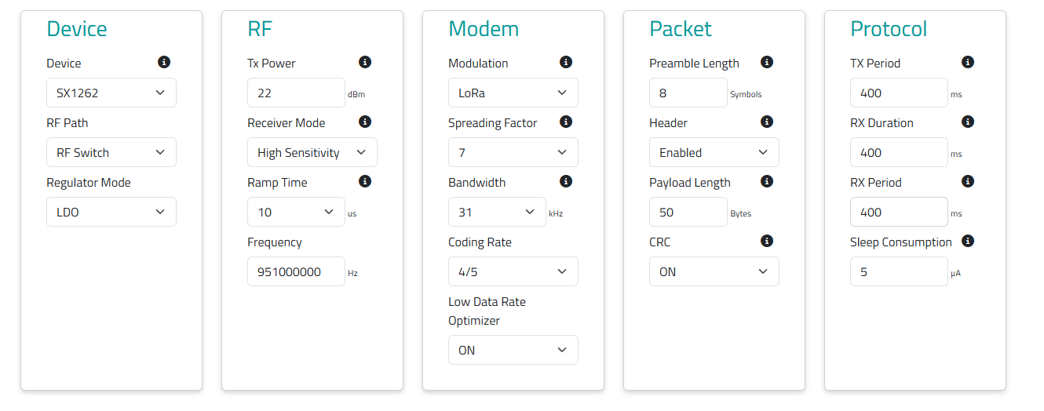
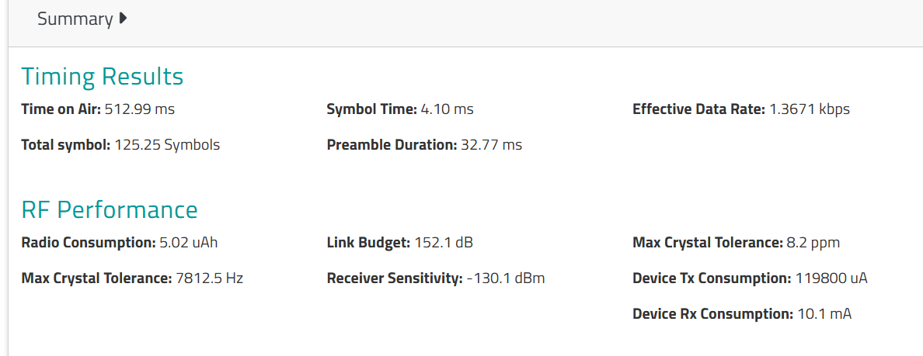

SF | BW | Time on air(s) | sym time (ms) | total symbol (syms) | Link budget (dB) | Rx sensitivity (dBm) | effective DR (bps)
7 | 10400 | 1.54 | 12.29 | 125.25 | 156.8 | -134.8 | 455.75
7 | 20000* | 0.769 | 6.14 | 125.25 | 153.8 | -131 | 911.44
7 | 31000* | 0.512 | 4.1 | 125.25 | 152.1 | -130.1 | 1367
7 | 125000 | 0.128 | 1.02 | 125.25 | 146 | -124 | 5468
7 | 500000 | 0.032 | 0.26 | 125.25 | 138 | -116 | 21875
12 | 10400 | 27.62 | 393.2 | 70.25 | 169.3 | -147.3 | 24.4
12 | 125000 | 2.3 | 32.77 | 70.25 | 158.5 | -136.5 | 292.96
12 | 500000 | 0.575 | 8.19 | 70.25 | 150.5 | -128.5 | 1171

Target similar DR with the higher SF/BW to compare performance.

SX1262 LoRa node chip
Max Tx 22dBm
Freq range 150MHz – 960MHz
BW range 7.8/10.4 – 500kHz
SF (chips/sym = 2^SF) = 5-12
Thermal noise power level estimate
10log10(delta f) – 173.8 dBm for BW in Hz.
